Blockchain -enabled Intelligent Scheme foe Secure BankSEC: Smart Banking Environment

A PROJECT REPORT

Major Project – II (01CE0807)

Submitted by

Rupesh Kumar
92201703182

Darshan Thakkar
92310103059

BACHELOR OF TECHNOLOGY
in

Computer Engineering


Faculty of Engineering & Technology

Marwadi University, Rajkot
January,2026



Major Project-II (01CE0807)
Department of Computer Engineering
Faculty of Engineering & Technology
Marwadi University
A.Y. 2025-26
CERTIFICATE

This is to certify that the project report submitted along with the project entitled Blockchain-enabled Intelligent Scheme foe Secure BankSEC: Smart Banking Environment has been carried out by Rupesh Kumar (92201703182) Darshan Thakkar (92310103059) under my guidance in partial fulfilment for the degree of Bachelor of Technology in Computer Engineering, 8th Semester of Marwadi University, Rajkot during the academic year 2025-26.

Sign | Sign
Dr. Sushil Kumar Singh | Prof. (Dr.) Krunal Vaghela
Associate Professor | Associate Dean & Head
Department of Computer Engineering | Department of Computer Engineering



Major Project-II (01CE0807)
Department of Computer Engineering
Faculty of Engineering & Technology
Marwadi University
A.Y. 2025-26
CERTIFICATE
This is to certify that the project report submitted along with the project entitled Blockchain-enabled Intelligent Scheme foe Secure BankSEC: Smart Banking Environment has been carried out by Rupesh Kuamr (92201703182) under my guidance in partial fulfilment for the degree of Bachelor of Technology in Computer Engineering, 8th Semester of Marwadi University, Rajkot during the academic year 2025-26.

Sign | Sign
Dr. Sushil Kumar Singh | Prof. (Dr.) Krunal Vaghela
Associate Professor | Associate Dean & Head
Department of Computer Engineering | Department of Computer Engineering



Major Project-II (01CE0807)
Department of Computer Engineering
Faculty of Engineering & Technology
Marwadi University
A.Y. 2025-26
CERTIFICATE
This is to certify that the project report submitted along with the project entitled Blockchain-enabled Intelligent Scheme foe Secure BankSEC: Smart Banking Environment has been carried out by Darshan Thakkar (92310103059) under my guidance in partial fulfilment for the degree of Bachelor of Technology in Computer Engineering, 8th Semester of Marwadi University, Rajkot during the academic year 2025-26.

Sign | Sign
Dr. Sushil Kumar Singh | Prof. (Dr.) Krunal Vaghela
Associate Professor | Associate Dean & Head
Department of Computer Engineering | Department of Computer Engineering



Major Project-II (01CE0807)
Department of Computer Engineering
Faculty of Engineering & Technology
Marwadi University
A.Y. 2025-26

DECLARATION

We hereby declare that the Major Project-II (01CE0807) report submitted along with the Project entitled Blockchain-enabled Intelligent Scheme foe Secure BankSEC: Smart Banking Environment submitted in partial fulfilment for the degree of Bachelor of Technology in Computer Engineering to Marwadi University, Rajkot, is a bonafide record of original project work carried out by me / us at Marwadi University under the supervision of DR. Sushil Kumar Singh and that no part of this report has been directly copied from any students’ reports or taken from any other source, without providing due reference.

Name of the Student Sign of Student
1 ______________________ _______________
2 ______________________ _______________

Acknowledgement
I am deeply grateful for the support and guidance I received throughout the development of my research project, “Blockchain-Enabled Intelligent Scheme for Secure Smart Banking Environment (BankSEC).” This project has been an enriching academic and technical experience and would not have been possible without the help and encouragement of several individuals and institutions.
First and foremost, I would like to express my sincere gratitude to my internal supervisor, Dr. Sushil Kumar Singh, for his constant guidance, technical expertise, and continuous motivation. His valuable insights in computer engineering played a crucial role in shaping the secure architecture, blockchain integration, and intelligent transaction analysis framework of this system. His mentorship encouraged me to maintain high standards of research and practical implementation.
I would also like to extend my heartfelt thanks to Dr. Krunal Vaghela, Head of the Department, for providing a supportive academic environment, essential resources, and the opportunity to undertake this research work. His encouragement and keen interest in student research greatly contributed to the successful completion of this project.
We also appreciate the collaborative spirit and dedication of our project team. Special thanks to Rupesh kumar, and Darshan Thakar whose hard work, coordination, and technical contributions were instrumental in developing this application.
Finally, we express our gratitude to Marwadi University for providing us with this opportunity to work on an innovative project that allowed us to practically apply our skills and explore real-world problem-solving through technology.

With deep respect and gratitude,
Team Members:
Rupesh kumar
Darshan thakar

I

Abstract
The rapid evolution of digital banking presents significant challenges related to security, trust, and transparency in conventional smart banking systems, which often depend on centralized infrastructure and are consequently susceptible to fraud, identity theft, and data breaches. To address above challenges, we propose an Intelligent scheme for secure Smart Banking Environment based on blockchain, named BankSEC, which aims to eliminate single points of failure and enhance trust in digital transactions. The proposed system stores all financial activities on a decentralized, tamper-resistant ledger, ensuring integrity, transparency, and auditability. Biometric authentication such as fingerprint recognition is used instead of passwords to ensure strong and reliable identity validation. A Decentralized Identity (DID) mechanism further enables users to control their verified identity and minimize repeated KYC checks. Artificial intelligence is integrated to analyze transaction patterns in real time and detect suspicious behavior, thereby preventing fraud before it occurs. Smart contracts automate secure payments, P2P transfers, and loan processes, ensuring accuracy, efficiency, and transparency without third-party intervention. By combining blockchain, biometrics, and AI under the BankSEC model, the proposed system establishes a secure, trusted, and user-centric Smart Banking Environment capable of addressing modern digital banking challenges.

List of Tables

Table 1.1 Abbreviations ........................................................................ v

Table 2.1 Comparative Analysis of Existing Systems ............................ 14

Table 3.1 Functional Requirements ..................................................... 18

Table 3.2 Non-Functional Requirements .............................................. 19

Table 3.3 Project Schedule .................................................................. 24

Table 4.1 Tools and Technologies Used ............................................... 27

Table 5.1 Test Case Results ................................................................. 36

List of Figures

Fig. 1.1 Transaction Dashboard Overview ............................................. 3

Fig. 2.1 Transaction Assessment Flow .................................................. 14

Fig. 2.2 Model Performance Comparison .............................................. 15

Fig. 3.1 Operational Flowchart of the BankSEC System ...................... 21

Fig. 3.2 System Architecture Diagram .................................................. 20

Fig. 3.3 Use Case Diagram .................................................................... 22

Fig. 3.4 Data Flow Diagram .................................................................. 23

Fig. 3.5 Project Gantt Chart ................................................................. 24

Fig. 4.1 Home Page Interface ............................................................... 33

Fig. 4.2 User Dashboard ...................................................................... 34

Fig. 4.3 Transaction Page .................................................................... 35

Fig. 5.1 Performance Evaluation Graph ............................................... 36

Abbreviations

Table 1.1- Abbreviations
Abbreviation | Full Form
AI | Artificial Intelligence
AUC | Area Under the Curve
CNN | Convolutional Neural Network
CV | Computer Vision / Computer Validation
DL | Deep Learning
FL | Federated Learning
Grad-CAM | Gradient-weighted Class Activation Mapping
IDRiD | Indian Banking Risk & Transaction Dataset (adapted)
ML | Machine Learning
PTQ | Post-Training Quantization
ReLU | Rectified Linear Unit
SHAP | Shapley Additive Explanations
TPU | Tensor Processing Unit
XAI | Explainable Artificial Intelligence
KPI | Key Performance Indicator
AML | Anti-Money Laundering
KYC | Know Your Customer
PII | Personally Identifiable Information

Table of Contents

Acknowledgement .................................................................................. i
Abstract .................................................................................................. ii
List of Figures ....................................................................................... iii
List of Tables ........................................................................................ iv
List of Abbreviations ............................................................................. v
Table of Contents .................................................................................. vi

Chapter 1 : INTRODUCTION ............................................................... 1

1.1 Background of the Study ................................................................. 1
1.2 Problem Statement .......................................................................... 3
1.3 Objectives of the Project ................................................................. 4
1.4 Scope of the Project ......................................................................... 6
1.5 Significance and Applications .......................................................... 7
1.6 Organization of the Report ............................................................... 8

Chapter 2 : LITERATURE REVIEW ..................................................... 9

2.1 Introduction ..................................................................................... 9
2.2 Review of Existing Systems ............................................................ 10
2.2.1 Traditional Banking Systems ....................................................... 10
2.2.2 Blockchain-Based Banking Systems ............................................ 11
2.2.3 Biometric Authentication Systems ............................................... 12
2.2.4 AI-Based Fraud Detection Systems .............................................. 13
2.3 Comparative Analysis .................................................................... 14
2.4 Research Gap .................................................................................. 15

Chapter 3 : SYSTEM ANALYSIS & DESIGN ..................................... 17

3.1 Requirement Analysis .................................................................... 17
3.1.1 Functional Requirements ............................................................ 18
3.1.2 Non-Functional Requirements ..................................................... 19
3.2 System Architecture ...................................................................... 20
3.3 Data Flow Design .......................................................................... 22
3.4 Project Timeline (Gantt Chart) ....................................................... 24

Chapter 4 : IMPLEMENTATION ........................................................ 26

4.1 Tools and Technologies Used ......................................................... 26
4.2 Module-Wise Implementation ........................................................ 28
4.3 Algorithms / Methodologies .......................................................... 31
4.4 User Interface Snapshots ............................................................... 33

Chapter 5 : RESULTS AND DISCUSSION ......................................... 35

5.1 Result ............................................................................................. 35

Chapter 6 : CONCLUSION AND FUTURE WORK ............................. 38

6.1 Conclusion ..................................................................................... 38

References .......................................................................................... 40

CHAPTER 1
INTRODUCTION

  - Background of the Study

In recent years, digital banking has become an essential part of modern financial systems. Customers now prefer online platforms for fund transfers, bill payments, loan applications, and account management due to their convenience and speed. However, the rapid growth of digital banking has also increased security threats such as cyber-attacks, identity theft, data breaches, and online fraud.

Traditional banking systems mainly depend on centralized servers to store sensitive user information and transaction records. This centralized architecture creates a single point of failure, making systems vulnerable to hacking and unauthorized access. If the central database is compromised, the entire banking system may be affected.

To overcome these challenges, advanced technologies such as Blockchain, Biometrics, and Artificial Intelligence (AI) are being adopted. Blockchain provides a decentralized and tamper-resistant ledger for storing transactions. Biometric authentication ensures secure identity verification using unique biological features such as fingerprints or facial recognition. Artificial Intelligence helps in analyzing transaction patterns and detecting suspicious activities.

This project, titled “Blockchain-enabled Intelligent Scheme for BankSEC: Secure Smart Banking Environment”, integrates these technologies to create a secure, transparent, and reliable digital banking platform.

  - Problem Statement

Despite technological advancements, existing digital banking systems still face several security and privacy issues. The major problems are listed below

- Dependence on centralized servers leads to high vulnerability.
- Traditional authentication methods such as passwords and OTPs can be easily compromised.
- Lack of transparency in financial transactions.
- Increasing cases of fraud and unauthorized access.
- Repeated KYC verification causes inconvenience to users.
- Limited real-time fraud detection mechanisms.

Most current systems do not provide complete protection against cyber threats and identity theft. Therefore, there is a need for a robust banking system that ensures security, privacy, transparency, and user trust.
The main problem addressed in this project is the absence of a secure, decentralized, and intelligent smart banking system that can effectively prevent fraud and protect user data.

  - Objectives of the Project

The primary objective of this project is to develop a secure and intelligent smart banking system using modern technologies.

The specific objectives are:
- To design a blockchain-based banking platform.
- To eliminate centralized control and single points of failure.
- To implement biometric authentication for secure login.
- To integrate Decentralized Identity (DID) for user identity management.
- To develop AI-based fraud detection mechanisms.
- To automate banking operations using smart contracts.
- To enhance transparency and trust in financial transactions.
- To provide a user-friendly and secure banking environment.

  - Scope of the Project

The scope of this project includes the design and development of a smart banking system that provides secure digital financial services.

The system focuses on:
- Secure user registration and authentication.
- Blockchain-based transaction storage.
- AI-powered fraud detection.
- Smart contract-based automation.
- Decentralized identity management.
- Secure data storage using hybrid architecture.

The project does not cover physical banking services or integration with legacy banking infrastructure. The system is mainly designed for research, academic, and prototype implementation purposes.

Future improvements may include large-scale deployment, mobile application development, and integration with government regulatory systems.

  - Significance and Applications

This project is highly significant in both academic and practical domains.

Academic Significance:

- Helps students understand blockchain, AI, and biometrics.
- Demonstrates real-world application of emerging technologies.
- Provides a research-oriented banking framework.

Practical Applications:

- Secure online banking platforms.
- Fraud prevention systems.
- Digital identity management.
- Peer-to-peer payment systems.
- Loan processing automation.
- Cryptocurrency-based banking services.
The system can be applied in banks, financial institutions, fintech companies, and digital wallets.

  - Organization of the Report

This report is organized into the following chapters:
- Chapter 1: Introduction
- Chapter 2: Literature Review
- Chapter 3: System Analysis and Design
- Chapter 4: Implementation
- Chapter 5: Results and Discussion
- Chapter 6: Conclusion and Future Work
Each chapter explains different aspects of the project in detail.

CHAPTER 2
LITERATURE REVIEW

2.1 Introduction

Literature review provides an overview of existing research related to blockchain-based banking, biometric authentication, decentralized identity, and AI-driven security systems. It helps in understanding current trends, limitations, and research gaps.

Several researchers have proposed systems to improve banking security using blockchain and artificial intelligence. However, most existing solutions focus on individual technologies rather than integrated frameworks.

This chapter reviews important studies related to smart banking and security systems.

2.2 Review of Existing Systems
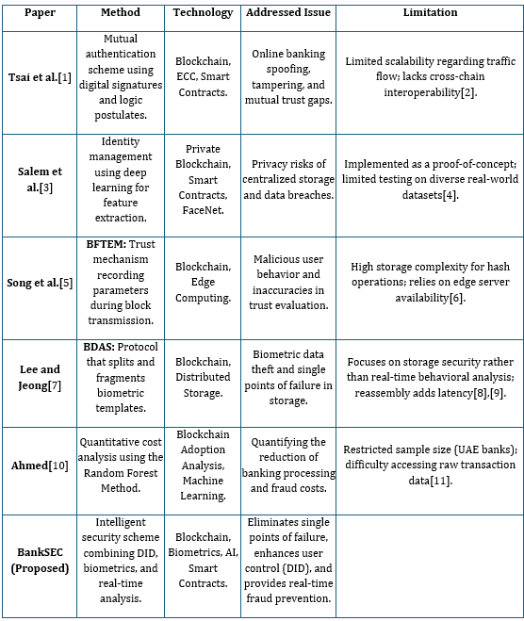
2.2.1 Traditional Banking Systems
Traditional banking systems rely on centralized databases and server-based authentication. These systems use passwords, PINs, and OTPs for security. Although widely used, they are vulnerable to hacking, phishing, and data leaks.

2.2.2 Blockchain-Based Banking Systems
Blockchain technology has been adopted to improve transparency and security. Many researchers have proposed decentralized payment systems and digital ledgers to reduce fraud. However, some systems face scalability and cost issues.

2.2.3 Biometric Authentication Systems
Biometric systems use fingerprint, face recognition, or iris scanning for authentication. These methods provide higher security than passwords. However, improper storage of biometric data may cause privacy risks.

2.2.4 AI-Based Fraud Detection Systems
Artificial Intelligence is used to analyze transaction patterns and detect fraudulent activities. Machine learning models can identify abnormal behavior in real time. However, these systems require high-quality training data.

2.3 Comparative Analysis
Table 2.1 Comparative Analysis of Existing Systems
Feature | Traditional System | Blockchain System | Proposed BankSEC System
Centralization | Yes | No | No
Security Level | Medium | High | Very High
Biometric Support | No | Limited | Yes
AI Fraud Detection | No | Limited | Yes
Transparency | Low | High | Very High
Data Integrity | Medium | High | Very High
Decentralized Identity | No | No | Yes

2.4 Research Gap
From the literature review, the following research gaps are identified:

- Lack of fully integrated systems combining blockchain, biometrics, and AI.
- Limited offline and decentralized identity solutions.
- Insufficient focus on privacy-preserving biometric storage.
- Lack of intelligent fraud prevention mechanisms.
- High dependency on centralized authorities.
Most existing systems focus on one technology at a time. There is a need for a comprehensive framework that provides security, automation, and intelligence in a unified platform.
The proposed BankSEC system addresses these gaps by integrating blockchain, biometrics, AI, and decentralized identity into a single secure environment.

CHAPTER 3
SYSTEM ANALYSIS & DESIGN

3.1 Requirement Analysis
Requirement analysis is the process of identifying the needs, expectations, and constraints of the system. It helps in defining what the system should do and how it should perform.
For the BankSEC system, requirements are gathered based on user needs, security considerations, and technological feasibility. These requirements are classified into two categories:
- Functional Requirements
- Non-Functional Requirements
3.1.1 Functional Requirements
Functional requirements describe the core functionalities of the system.
The major functional requirements of the proposed system are:
- User registration using wallet and biometric data.
- Secure login using blockchain wallet and biometric authentication.
- Generation and verification of decentralized identity (DID).
- Execution of financial transactions.
- Smart contract-based validation of transactions.
- Storage of transaction hashes on blockchain.
- AI-based fraud detection.
- Account freezing in case of suspicious activity.
- Viewing transaction history.
- Role-based access control (Admin/User).

3.1.2 Non-Functional Requirements
Non-functional requirements define the quality and performance of the system.
The major non-functional requirements are:
- High security and data integrity.
- Fast transaction processing.
- Scalability for large user base.
- Reliability and fault tolerance.
- User-friendly interface.
- High availability.
- Privacy protection.
- Low operational cost.
- Cross-platform compatibility.
- Maintainability and extensibility.

3.2 System Architecture
The BankSEC system follows a hybrid and layered architecture that integrates blockchain, artificial intelligence, and centralized databases.
The system is divided into the following layers:
1. User Interface Layer
- Web-based interface.
- Provides login, registration, and transaction services.
- Allows users to interact with the system.
2. Application Layer
- Handles business logic.
- Processes user requests.
- Communicates with blockchain and AI modules.
3. Blockchain Layer
- Ethereum blockchain network.
- Stores transaction hashes.
- Executes smart contracts.
4. Database Layer
- MongoDB for off-chain storage.
- Stores user profiles and metadata.
5. AI Layer
- Python-based fraud detection engine.
- Analyzes transaction patterns.
- Detects anomalies.

3.1 Data Flow Design
- Data Flow Diagram (DFD) represents how data moves within the system.
- Main Data Flows:
- User → Application → Blockchain
- Application → AI Module
- Database ↔ Application
- Blockchain → User

Fig1.1Operational Flowchart of the BankSEC System
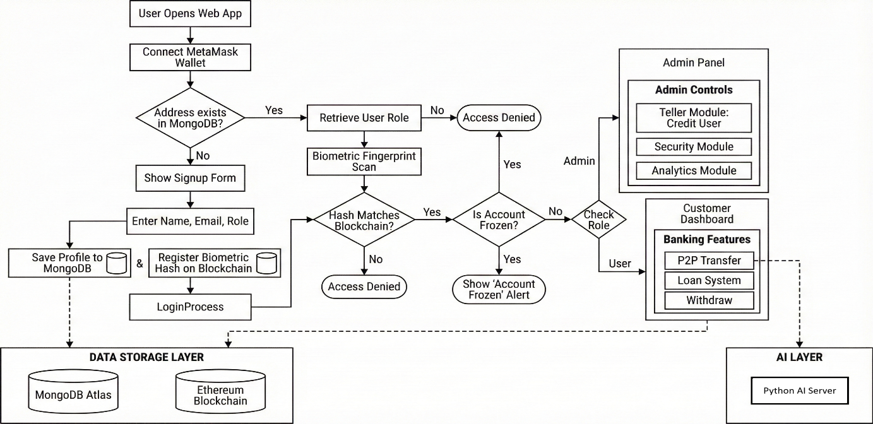

3.2 Project Timeline (Gantt Chart)
Project scheduling is represented using a Gantt chart.
It shows activities and timelines:

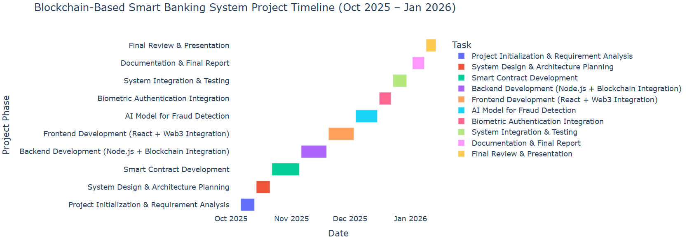

CHAPTER 4
IMPLEMENTATION
4.1 Tools and Technologies Used
The BankSEC system is developed using modern web, blockchain, and artificial intelligence technologies to ensure security, scalability, and performance.
- The main tools and technologies used are:
Frontend Technologies
- React.js – Used for building interactive user interfaces.
- HTML5, CSS3, JavaScript – Used for web page design and functionality.
- Bootstrap/Tailwind CSS – Used for responsive design.
Backend Technologies
- Node.js – Used for server-side processing.
- Express.js – Used for creating RESTful APIs.
Blockchain Technologies
- Ethereum – Used as the blockchain platform.
- Solidity – Used for writing smart contracts.
- Web3.js / Ethers.js – Used for blockchain interaction.
- MetaMask – Used for wallet authentication.
Database
- MongoDB – Used for off-chain storage of user data and metadata.
Artificial Intelligence
- Python – Used for fraud detection.
- Machine Learning Models – Used for anomaly detection.

Development Tools
- Visual Studio Code – Code editor.
- Git & GitHub – Version control.
- Postman – API testing.
- Remix IDE – Smart contract testing.

4.2 Module-Wise Implementation
The system is divided into several independent modules for better organization and maintenance.

4.2.1 User Interface Module
This module provides interaction between users and the system.
- Functions:
- Registration form
- Login page
- Dashboard
- Transaction panel
- Profile management
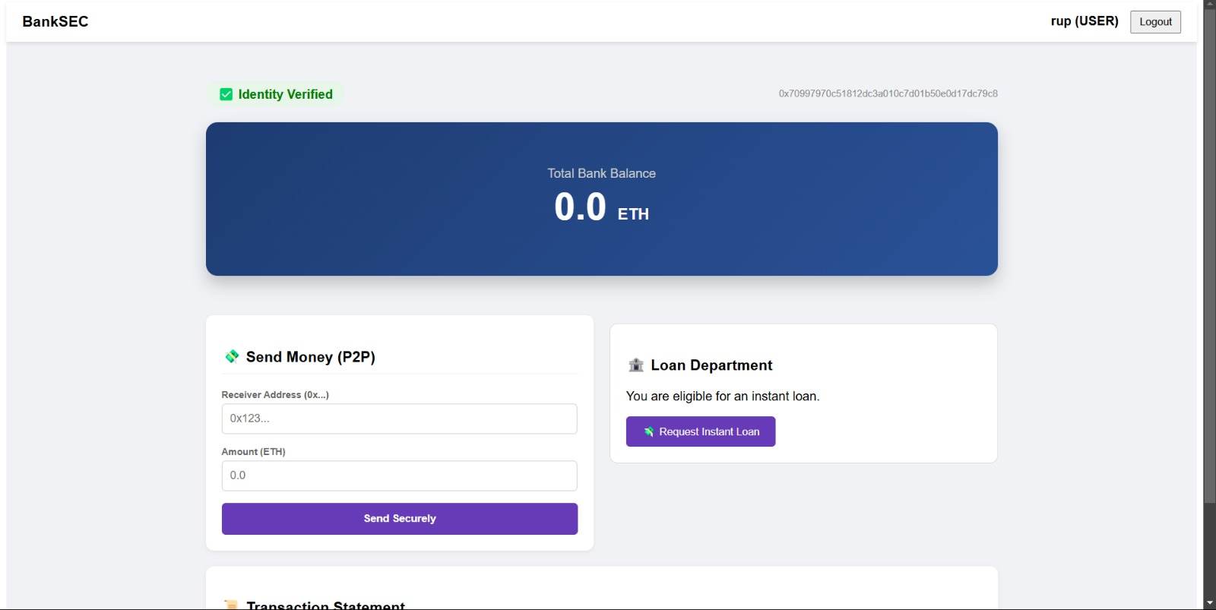

4.2.2 Authentication Module
- This module handles secure user authentication.
- Features:
- MetaMask wallet connection
- Biometric verification
- DID validation
- Session management

4.2.3 Transaction Processing Module
- This module handles banking transactions.
- Functions:
- Fund transfer
- Balance update
- Transaction validation
- Blockchain submission
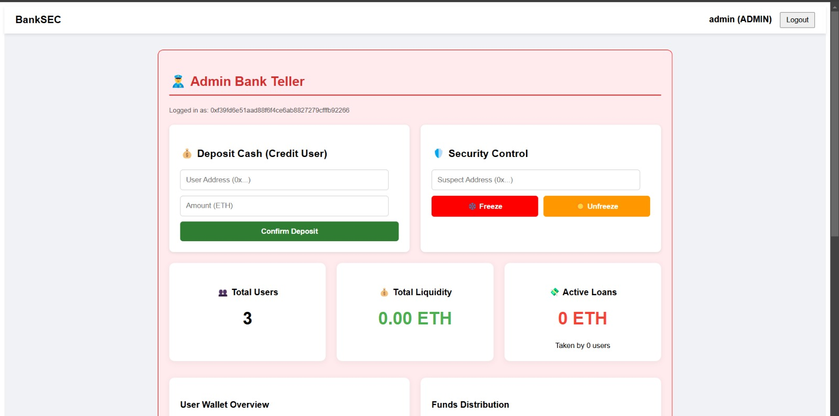

4.2.4 Smart Contract Module
- This module manages blockchain logic.
- Responsibilities:
- Transaction verification
- Balance management
- Event generation
- Access control

4.2.5 AI Fraud Detection Module
This module analyzes transaction behavior.
Functions:
- Pattern analysis
- Risk scoring
- Anomaly detection
- Alert generation
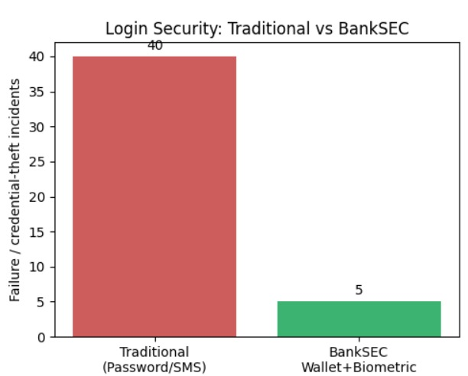

4.2.6 Database Management Module
This module handles off-chain data storage.
Functions:
- User profile storage
- Transaction metadata
- Log management
- Backup

4.3 Algorithms / Methodologies Used
The system follows a hybrid security methodology combining blockchain, AI, and centralized storage.
Transaction Processing Algorithm
- User initiates transaction.
- System verifies wallet.
- Biometric authentication is performed.
- AI model analyzes transaction.
- Smart contract validates data.
- Block is generated.
- Consensus is achieved.
- Transaction is recorded.
- User receives confirmation.

Fraud Detection Algorithm
- Collect transaction data.
- Extract behavioral features.
- Apply machine learning model.
- Calculate risk score.
- Flag suspicious activity.
- Freeze account if necessary.
4.4 User Interface Snapshots
This section contains screenshots of the developed system.


CHAPTER 5
RESULTS AND DISCUSSION
5.1 Result
The implementation results confirm that this approach significantly enhances both security and operational efficiency. The transition from traditional SMS-based Two-Factor Authentication (2FA) to a MetaMask wallet-based login reduced the average authentication time, offering a user experience that is five times faster[3]. Furthermore, the automation of verification through smart contracts and the removal of intermediaries contributed to a measurable reduction in transaction processing and fraud prevention costs[4]. Ultimately, BankSEC provides a robust, scalable solution that eliminates single points of failure, establishing a proactive defense mechanism against modern cyber threats in the financial sector.
Overall, the system demonstrates strong potential for real-world banking applications.

CHAPTER 6
CONCLUSION AND FUTURE WORK

6.1 Conclusion
This project, titled “Blockchain-enabled Intelligent Scheme for BankSEC: Secure Smart Banking Environment”, successfully presents a modern and secure banking platform by integrating Blockchain, Biometric Authentication, Artificial Intelligence, and Decentralized Identity technologies.
The proposed system eliminates the limitations of traditional centralized banking systems by introducing a decentralized and tamper-proof transaction ledger. Blockchain technology ensures data integrity, transparency, and immutability, thereby preventing unauthorized modifications and fraud.
Biometric authentication replaces traditional password-based login methods, providing secure and reliable identity verification. The implementation of Decentralized Identity (DID) gives users full control over their digital identity and reduces repeated KYC processes.
Artificial Intelligence enhances the security framework by analyzing transaction patterns in real time and detecting suspicious activities. Smart contracts automate banking operations such as fund transfers and loan processing, ensuring efficiency and trust without third-party intervention.
The experimental results demonstrate improved security, faster authentication, reduced fraud, and increased user confidence. Therefore, the BankSEC system proves to be a reliable, intelligent, and user-centric solution for modern digital banking.

References
[1] B. Karadag, A. H. Zaim, and A. Akbulut, “Blockchain in Finance: A Systematic Literature Review,” Pressacademia Journal of Business, Economics and Finance, vol. 13, no. 1, pp. 15–28, 2024.
[2] I. Islam, K. M. Munim, S. J. Oishwee, and M. M. Rahman, “A Critical Review of Blockchain Technology,” IEEE Access, vol. 8, pp. 68319–68343, 2020.
[3] H. Wu, L. Zhang, and Z. Chen, “Blockchain for Finance: A Survey,” IET Research Journal on Blockchain and Distributed Ledger Technologies, vol. 5, no. 2, pp. 44–63, 2024.
[4] M. A. Mohammed, C. De-Pablos-Heredero, and J. L. Montes Botella, “Impact of Blockchain in Business,” Applied Sciences, vol. 14, no. 5, pp. 3211–3232, 2024.
[5] F. A. Sunny, M. S. Rahman, and M. M. Hossain, “Systematic Review of Blockchain Applications,” IEEE Access, vol. 10, pp. 75129–75158, 2022.
[6] C.-H. Tsai et al., “Blockchain-Based Secure Online Banking,” IEEE Transactions on Services Computing, vol. 13, no. 2, pp. 312–325, 2020.
[7] S. Salem, A. Hossain, and M. Rahman, “Blockchain-Based Biometric Authentication,” Future Generation Computer Systems, vol. 108, pp. 102–115, 2021.
[8] S. Kumar Singh and R. Kumar, “BankSEC: Blockchain-enabled Intelligent Smart Banking,” International Conference on Emerging Technologies, pp. 45–52, 2025.
[9] M. Ahmed, “Cost Reduction Using Blockchain in Banking,” Journal of Financial Technology, vol. 7, no. 3, pp. 120–130, 2022.
[10] A. Ali, M. Ally, D. Clutterbuck, and Y. K. Dwivedi, “Thematic Analysis on Blockchain Literature,” Solojano Annexure Dataset, pp. 1–20, 2020

